LARK MESSAGE

For Version:Beta1



|  |  |
| --- | --- |
| Group Mumber(group 03) | Student Id |
| Guangen Xiao | 19107773 |
| Zijian Li | 19107692 |
| Hao Yuan | 19107684 |
| Jiawen Leng | 19108842 |

Date:Apr/17th/2020

Context

LARK MESSAGE 1

Introduction: 3

language 3

Login Function: 3

Register Function: 5

Home page: 5

Message Page: 6

Gallery Page: 6

Logout function 7

Setting function: 7

## Introduction:

Lark message is an moble application that was designed for people daily communication.We hope we can do a free and efficent app ,which people can share the idea or attidtude at a moment.

## language

First lets start with language, our app support multiple language. And, it depends on your language choice. Now ,we have German ,Chinese and English.

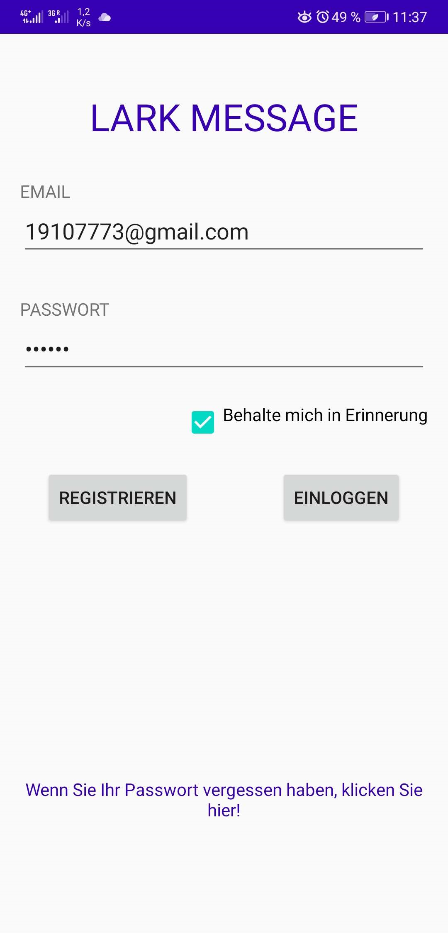 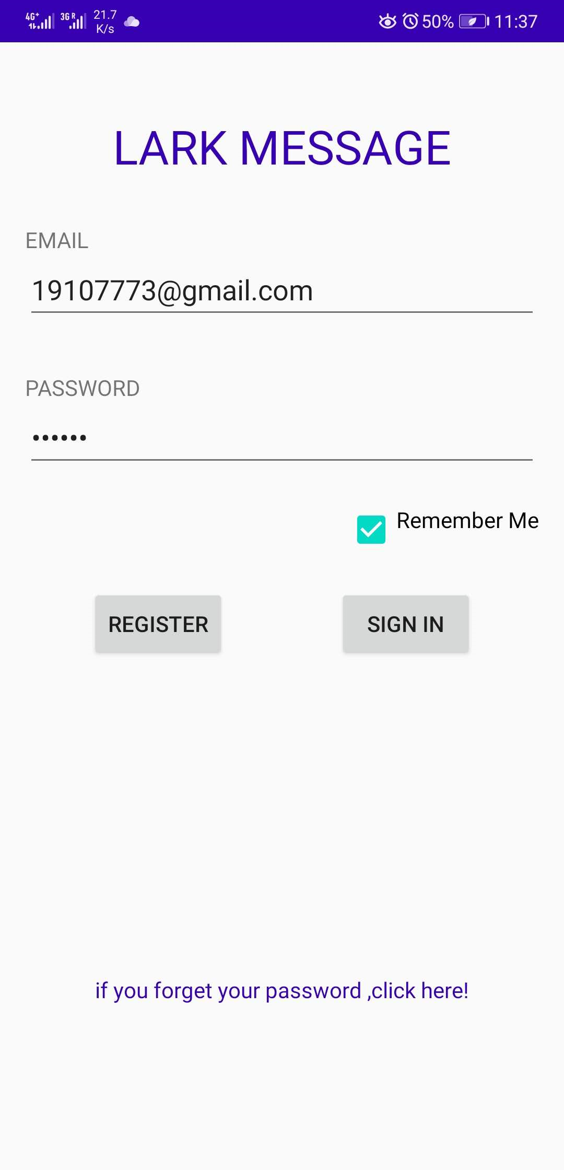 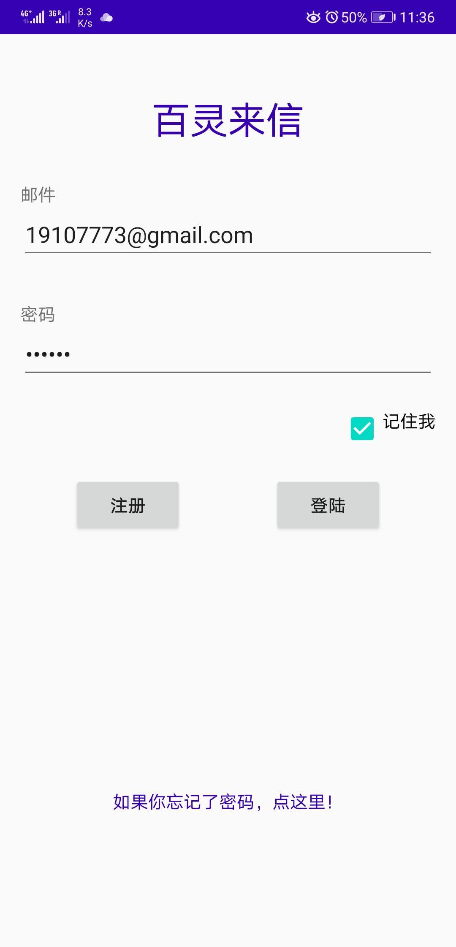

## Login Function:

For the login page,you have two methods to login your account. Absolutely ,you can use your email and password to login your account. If you forget your password,you can click that text. By this dialog ,you can use your email and phone number to get your password.(you don’t need to type it again we will do that for you! ).

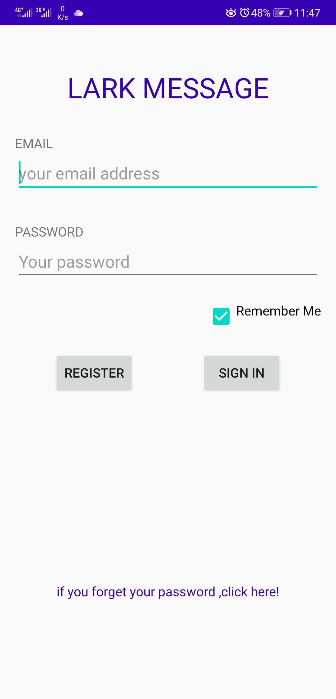 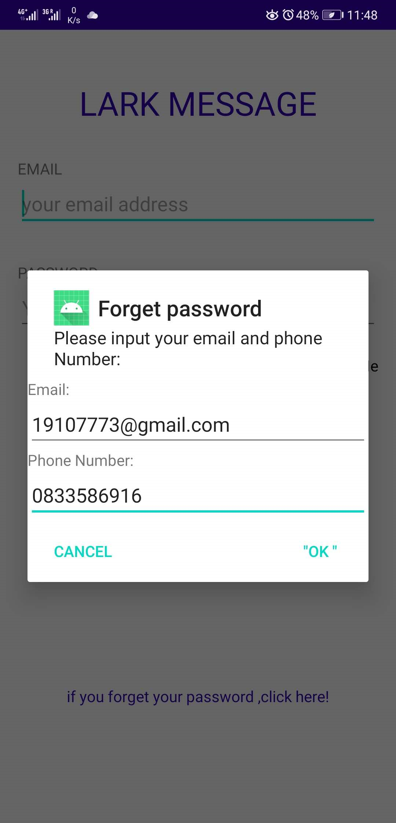 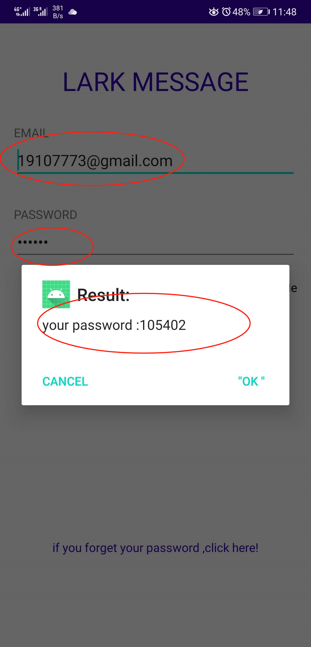

Absolutely, if you want our app record your password and account,you can choose “remember me”. Then in the next time you use the app, you don’t need to type these information again.

|  |  |  |
| --- | --- | --- |
|  | Remember me |  |
| Don’t Remember me |  |

## Register Function:

If you want to register an account ,you should use a correct email address(every email address can be registered one time.) And, we give you a chance to choose your icon(In the beta version ,you can’t change it forever! So, please choose your favorite one!).if your want to check your password, you can use the swith (hide your password) to show your password.

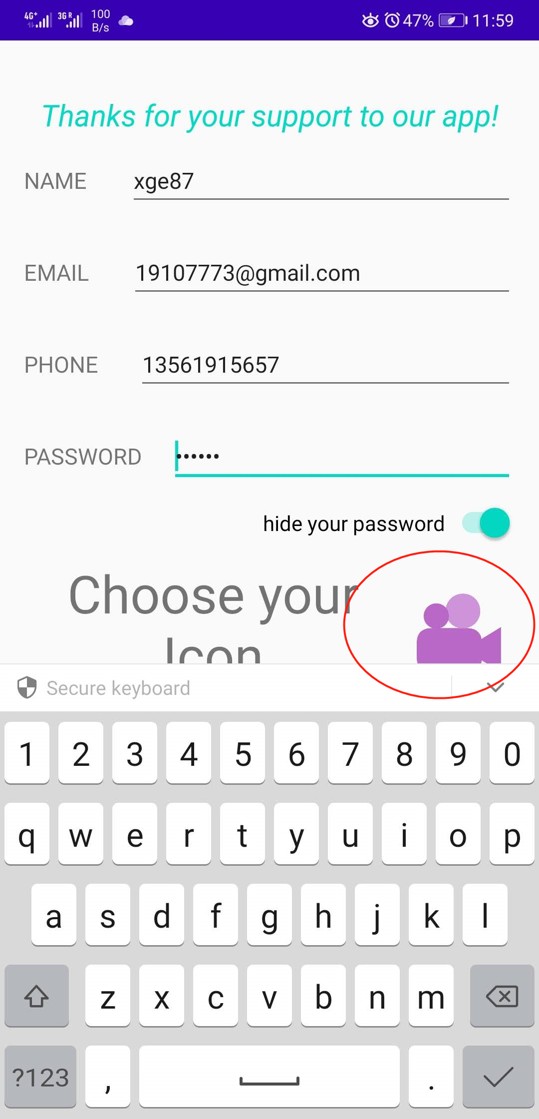 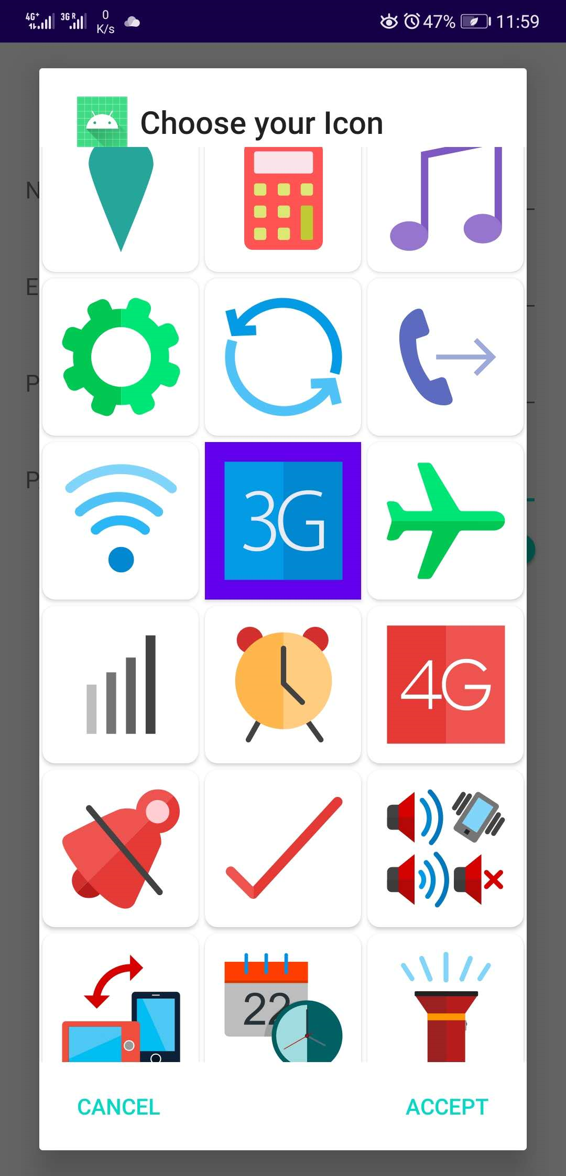 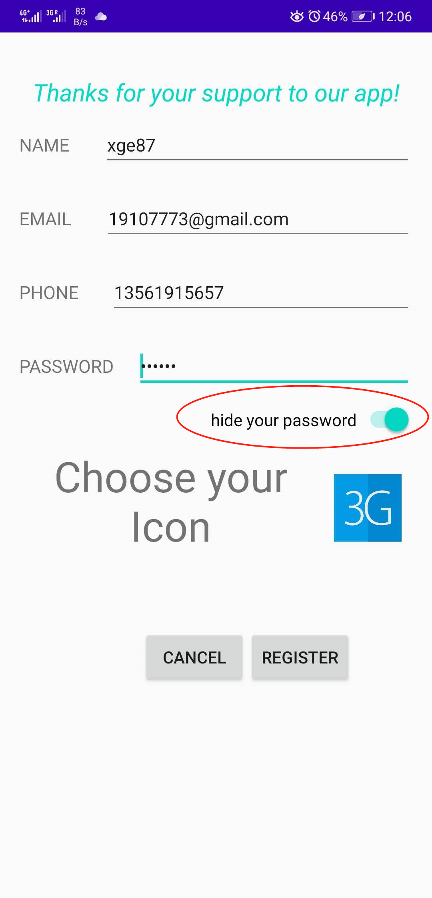 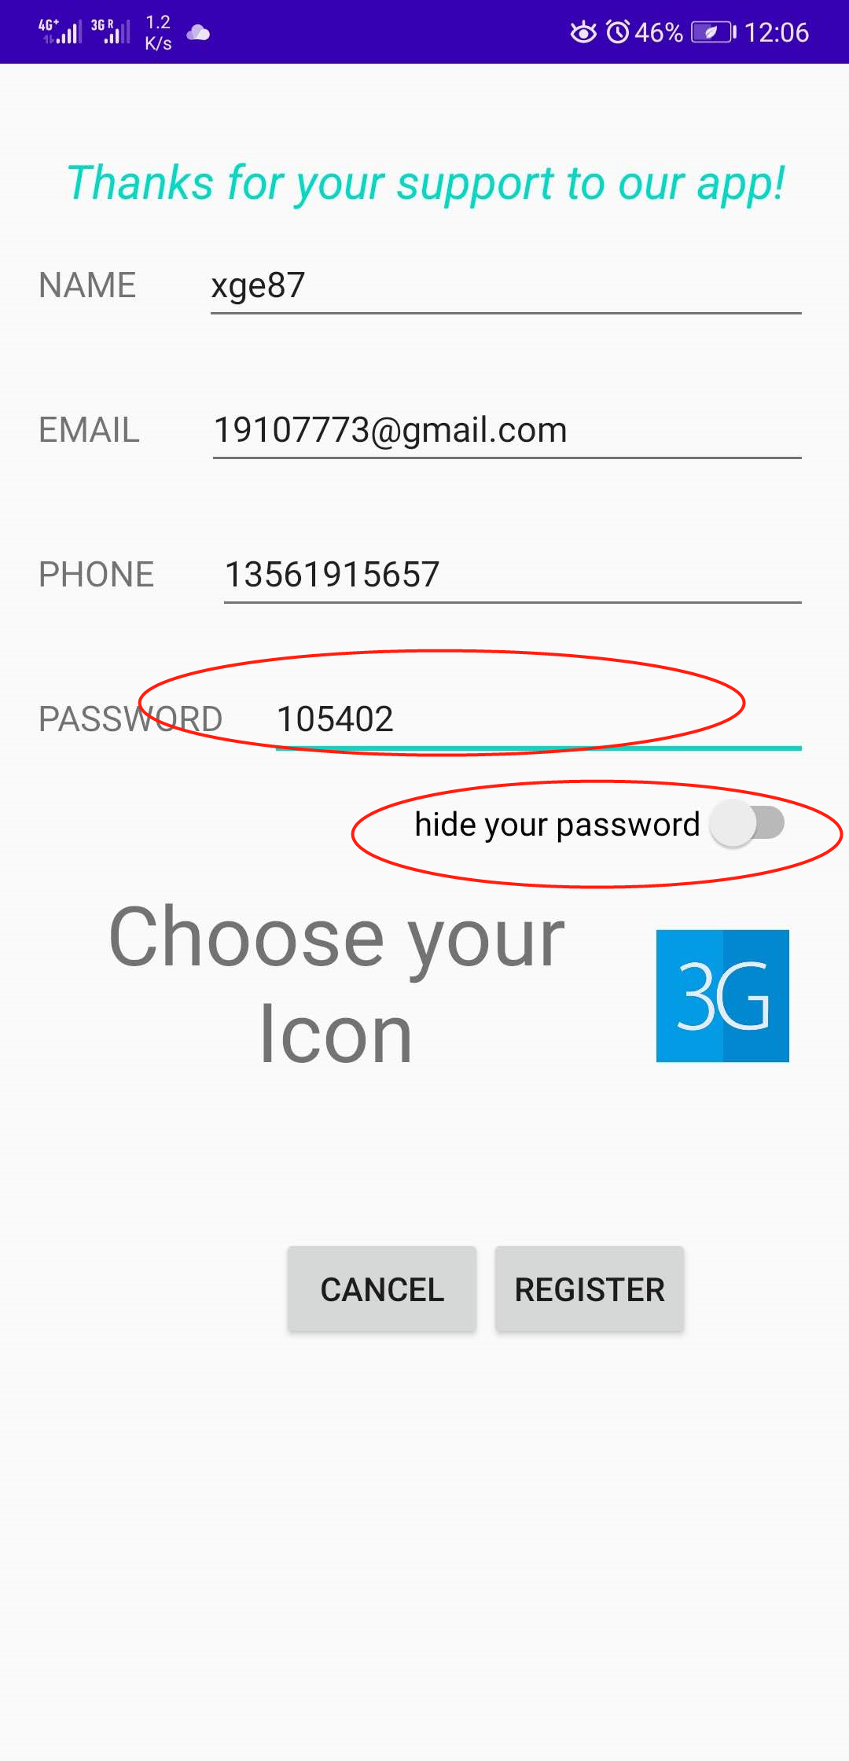

## Home page:

In this page , our app will show you your friends list! If you are using a new account,absolutely, you don’t have any friends.So, lets add someone by their email address! Frankly, you can’t add some one directly, need waiting for their respone! If they accept your invation ,just click their information item,and you can chat with your friend! In the message page,you can see your friends is on line or offline.

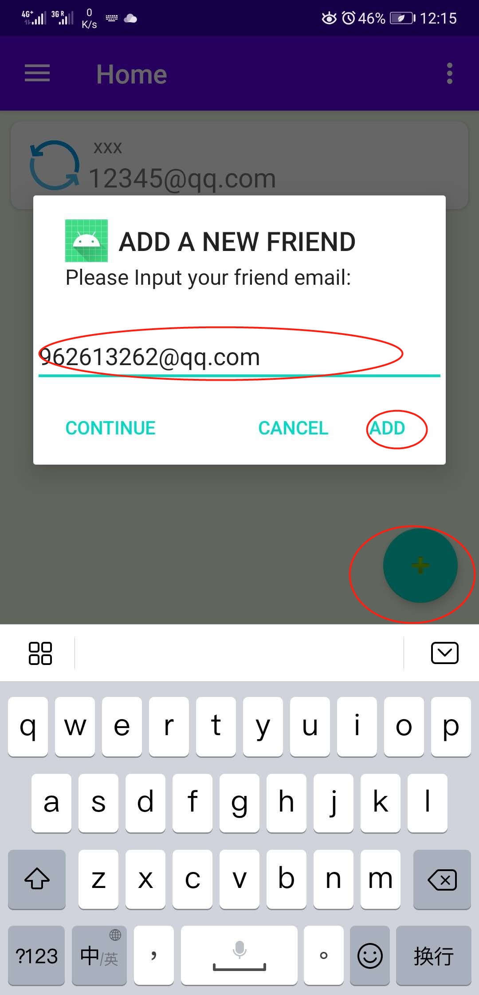 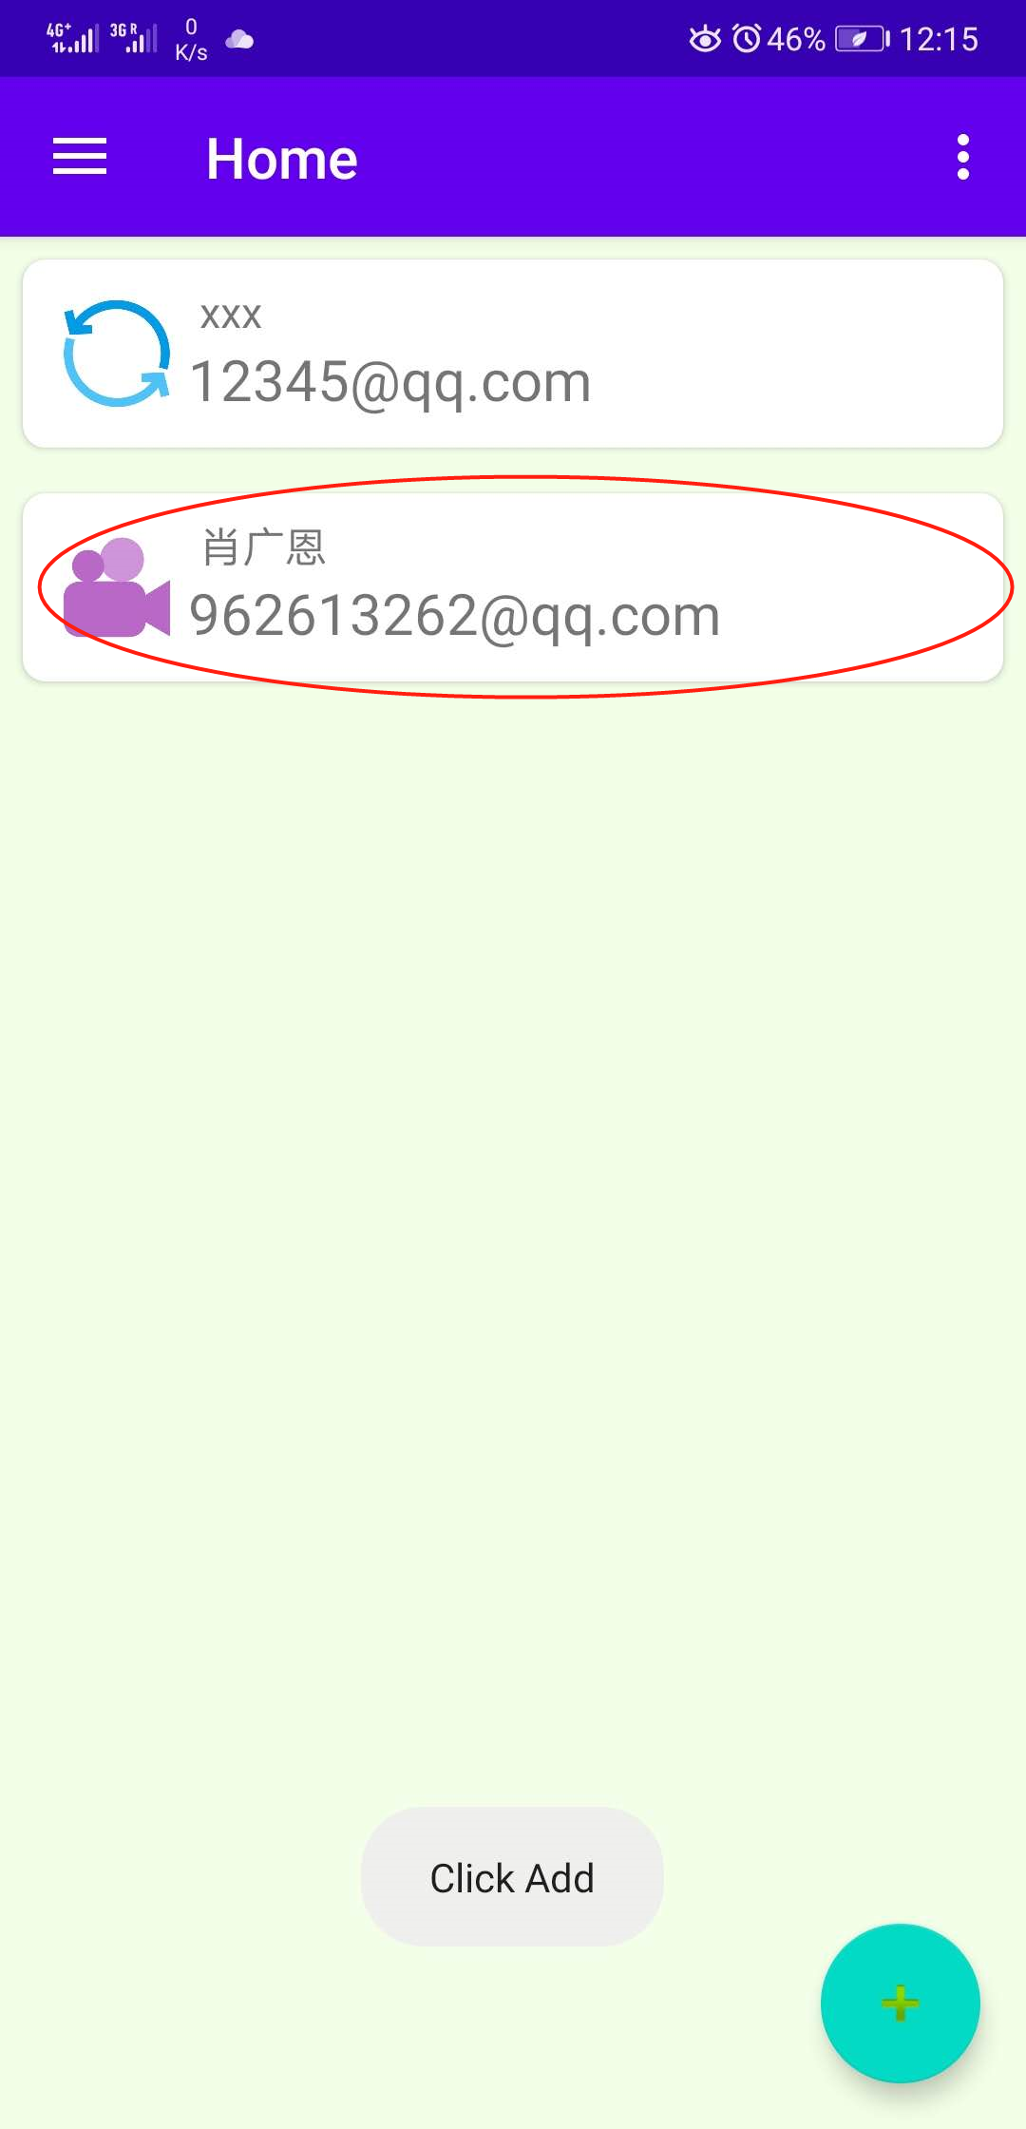 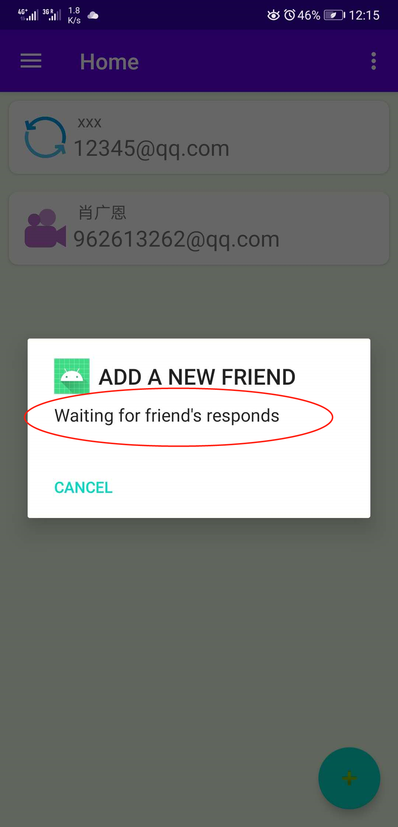 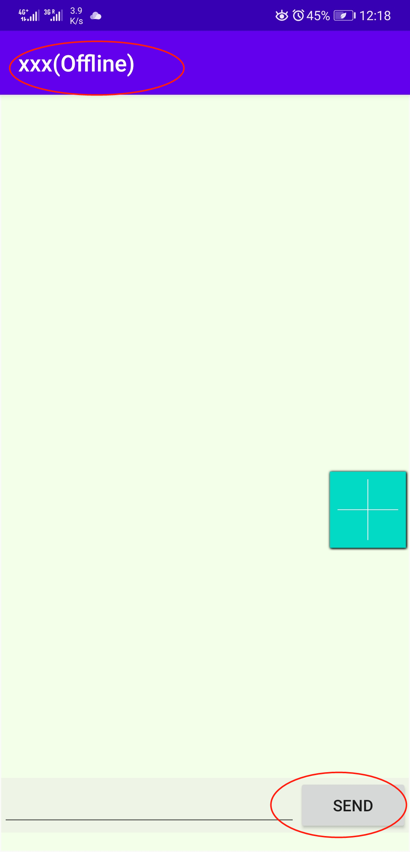

If you add a new friend , him will receive notification like this:

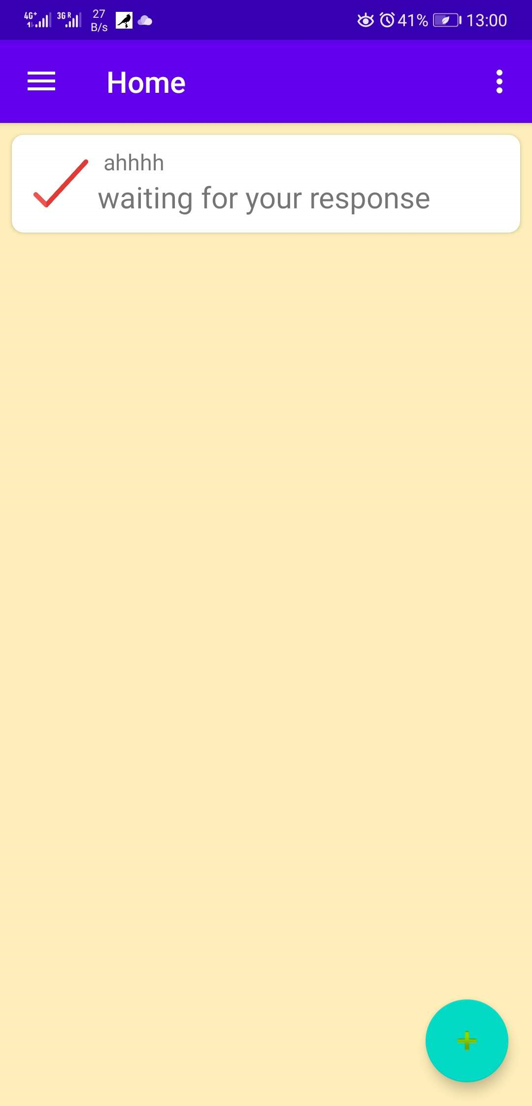 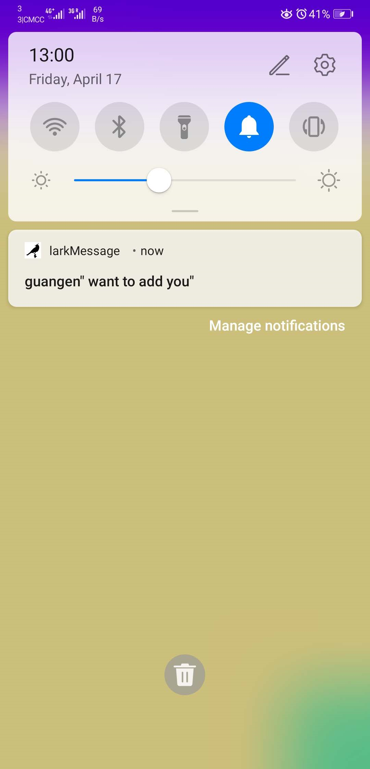 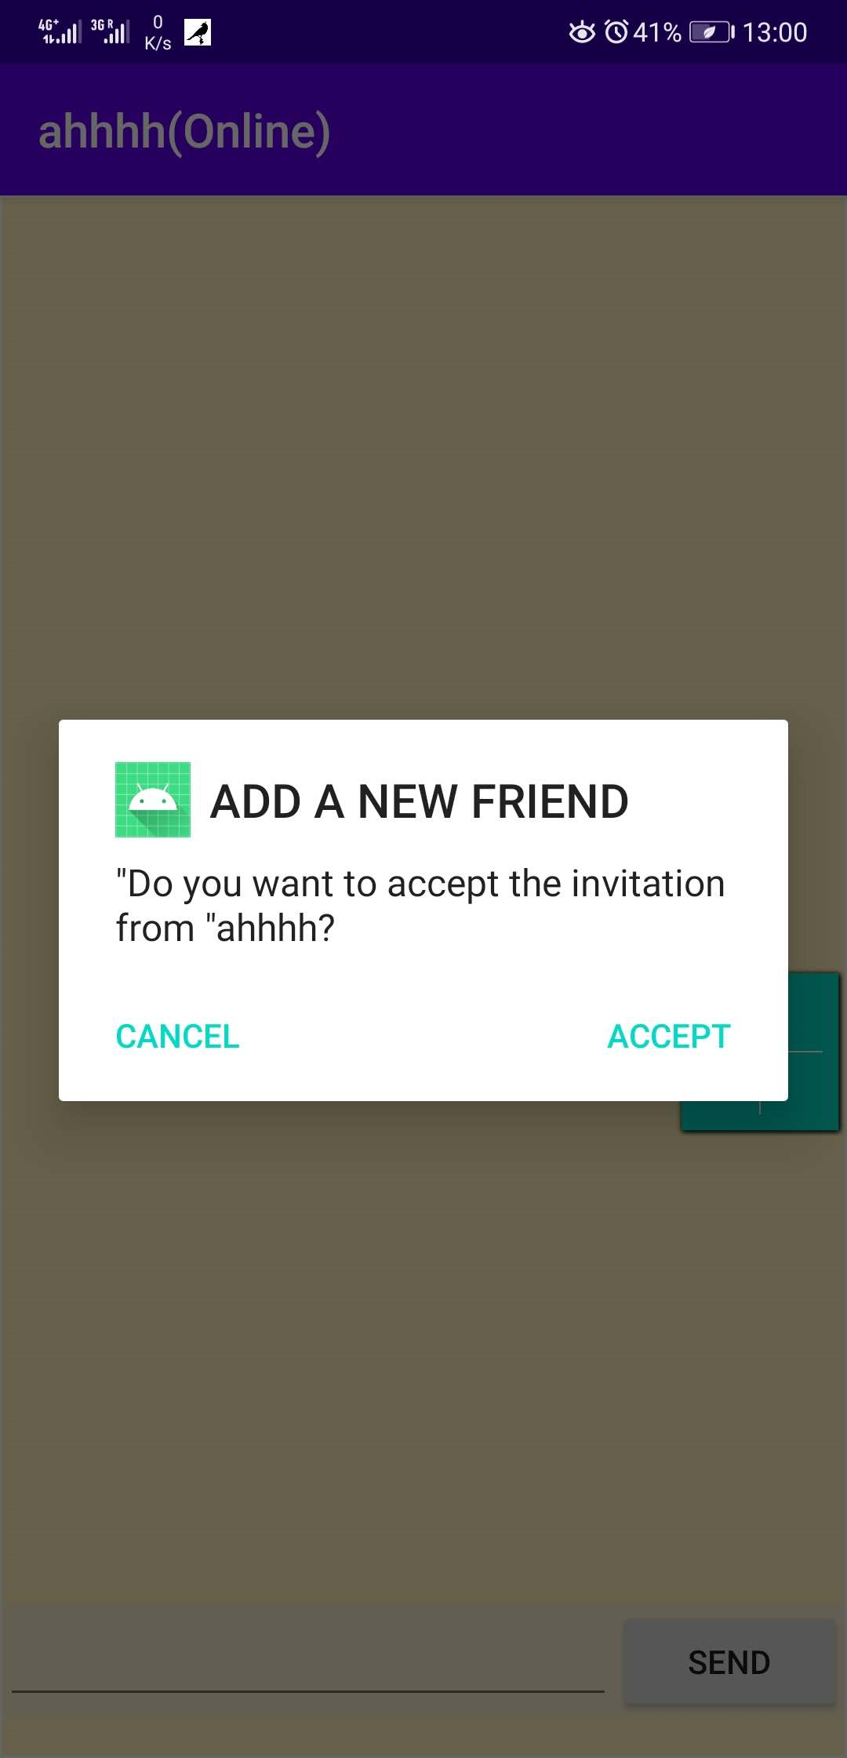

## Message Page:

We not only can send message. You also can mange your friend relation,send a picture or share location with your friends!(Because we need to protect every’s private information, we only access your location when you use the sharelocation function! So, if your friend are not using sharelocation function,we will show you the last location which he had shown you.)(if you want delete message ,just long click it.)

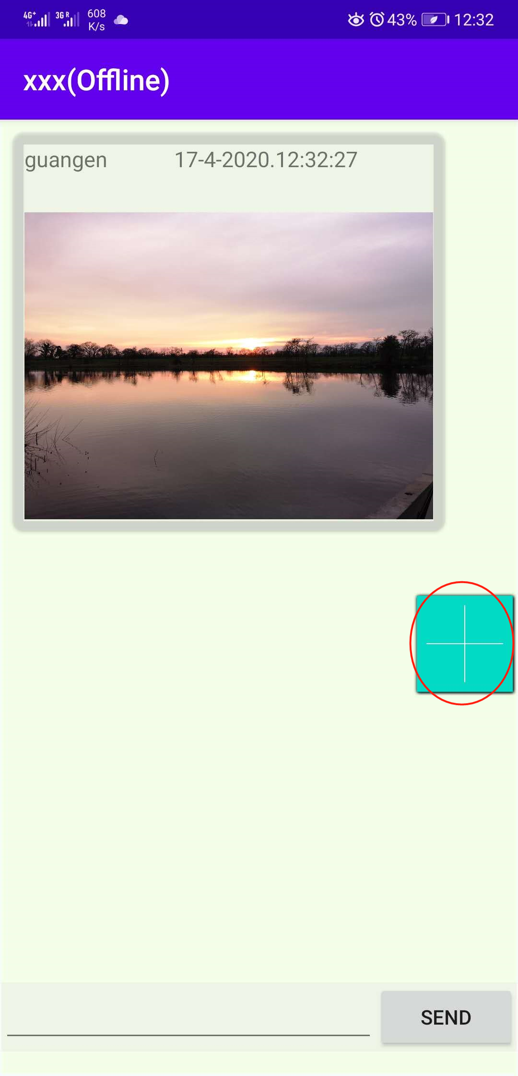 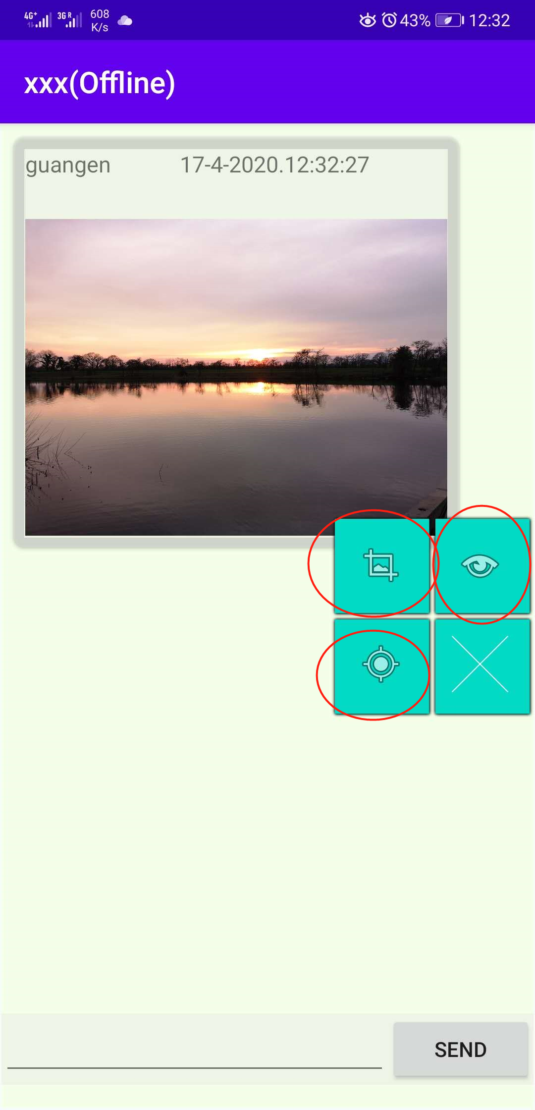 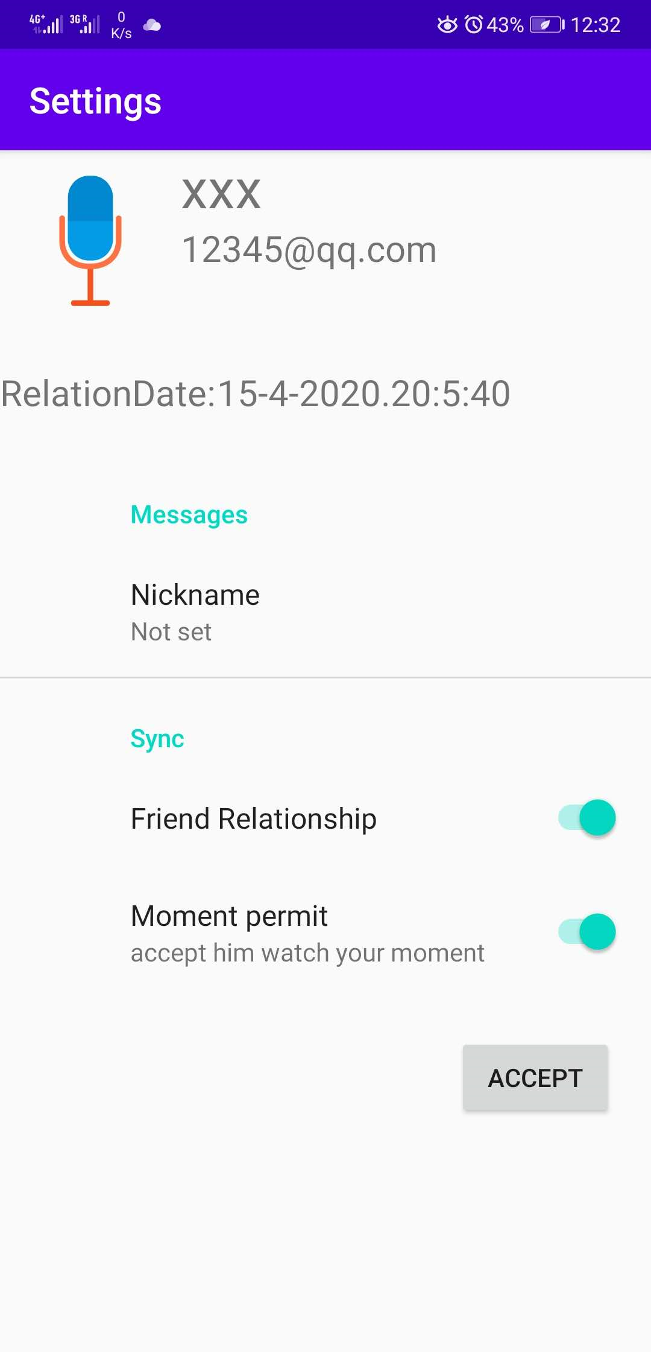 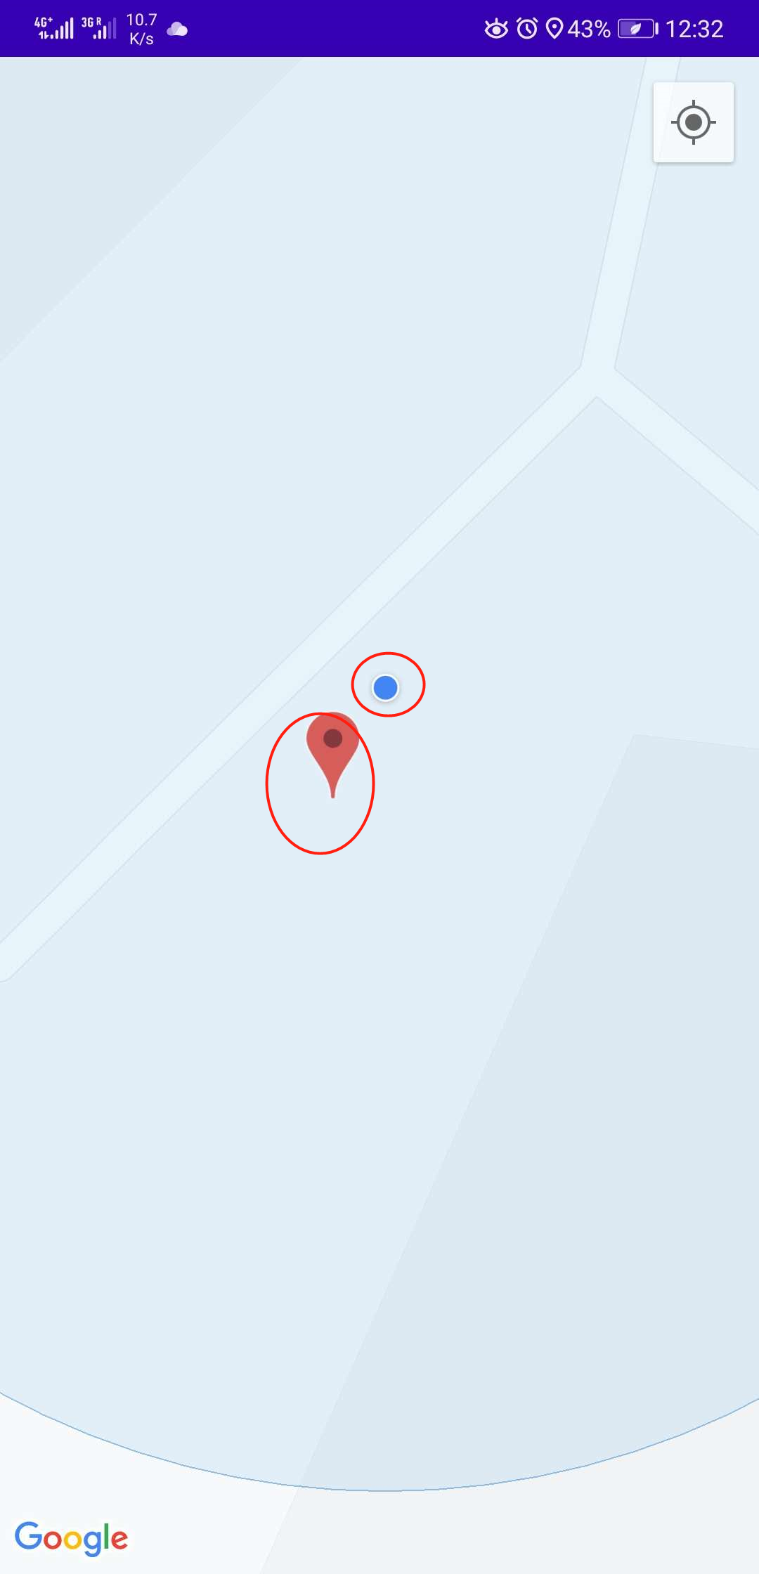

## Gallery Page:

In this page ,you can see your friend’s moment(Which has been sent after add you!) You also can sent a moment or delete them.(If you are not the sender , you can’t delete you only can ignore them!).You can like someone’s moment and find who agree with you!

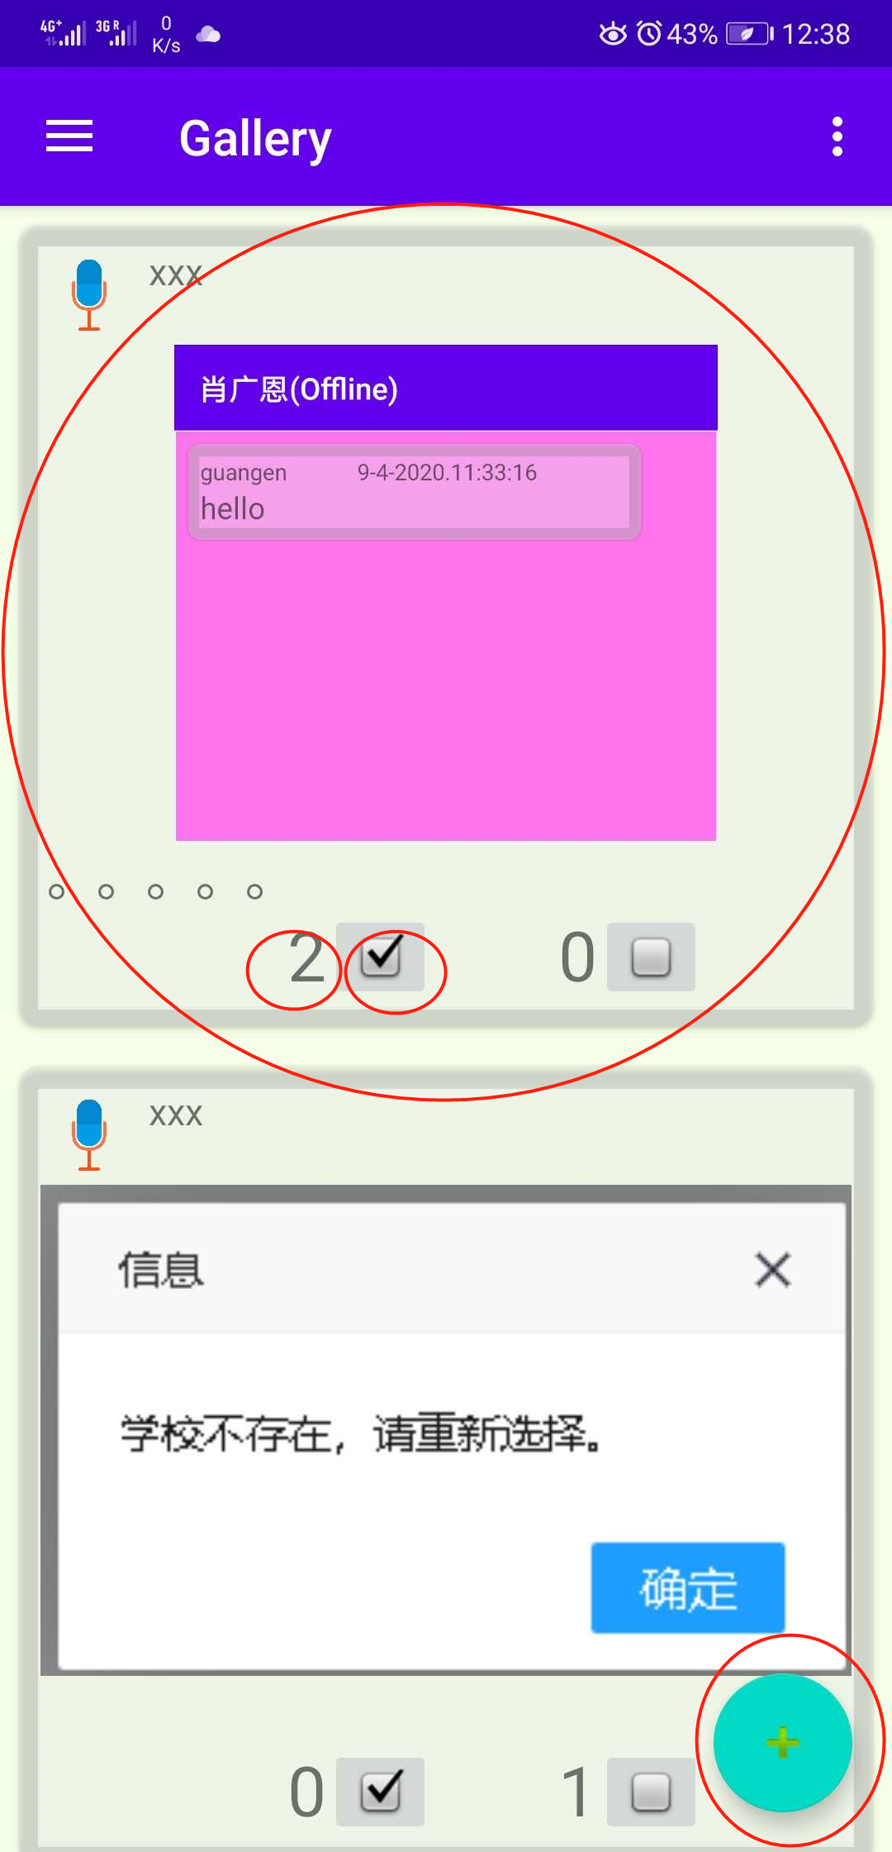 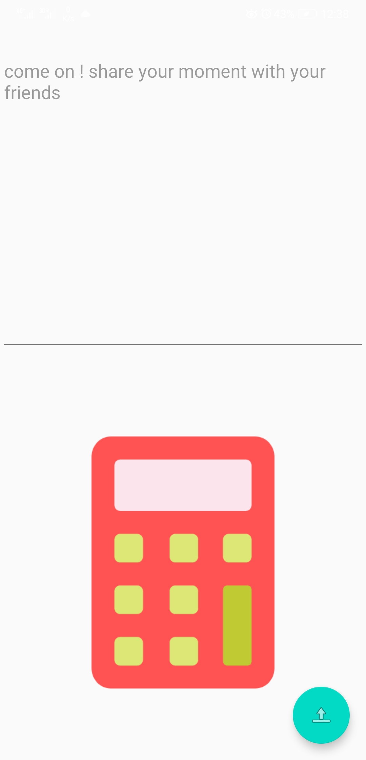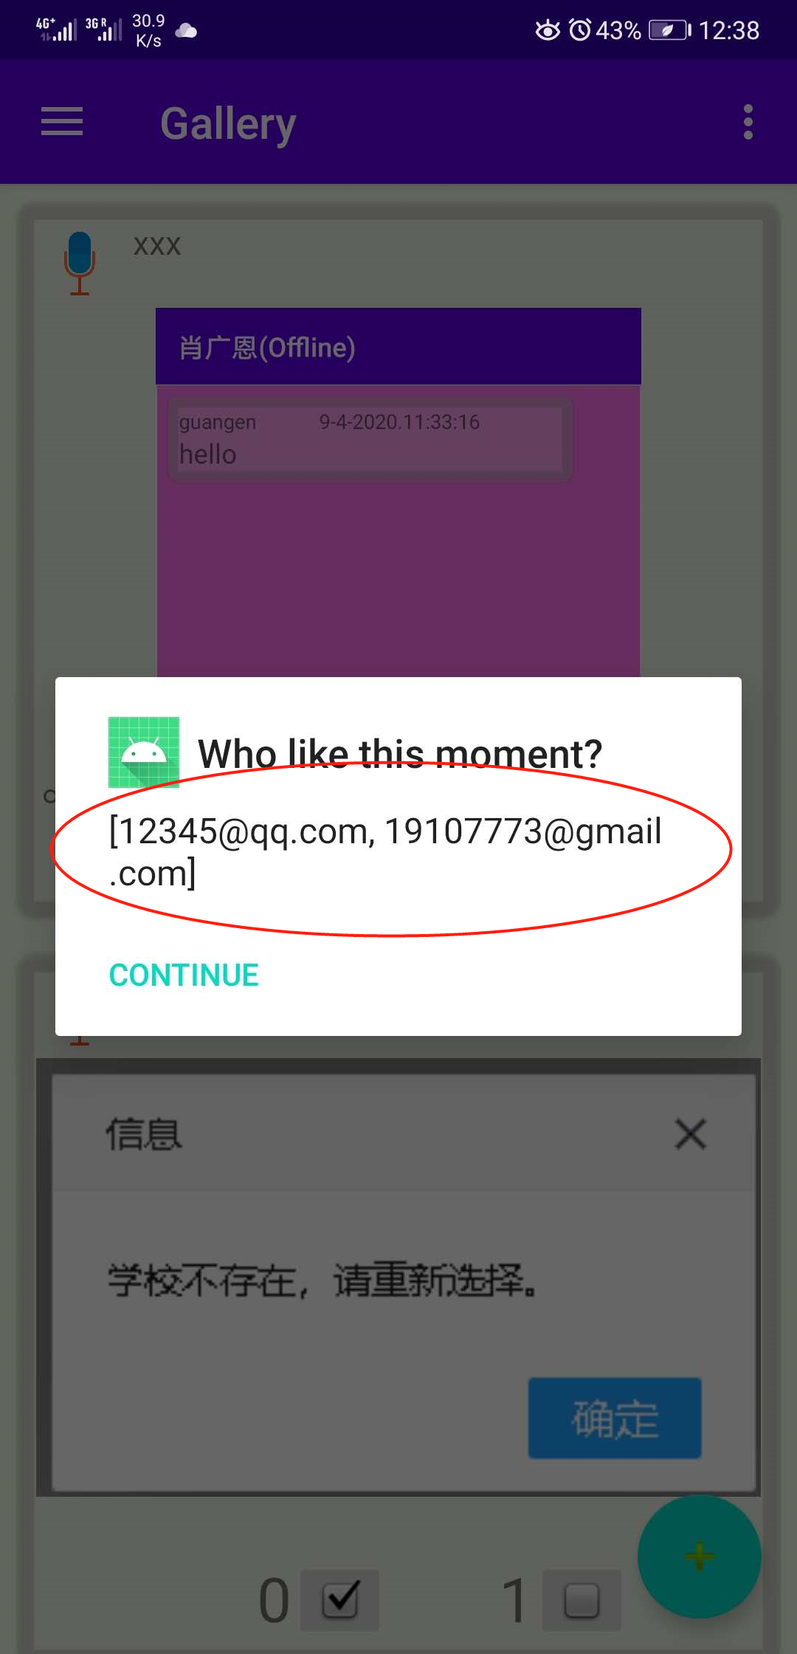 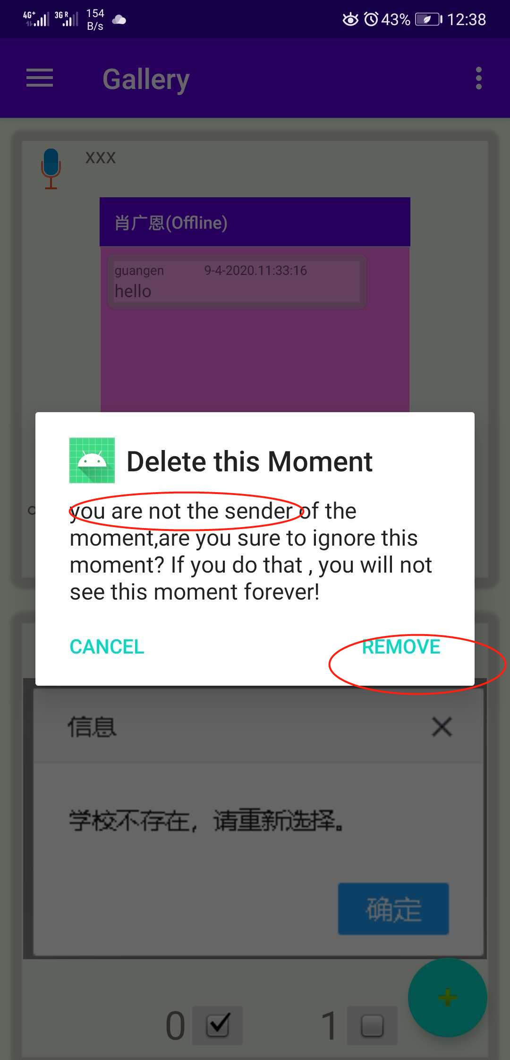

## Logout function

It’s just a logout page,but we really grateful for your using!

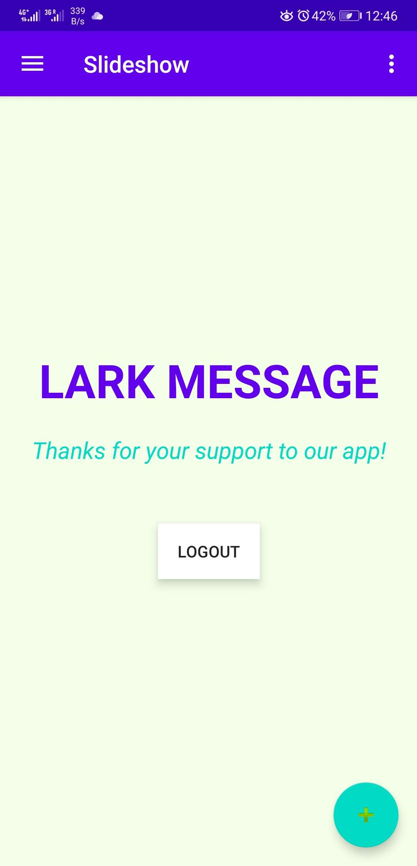 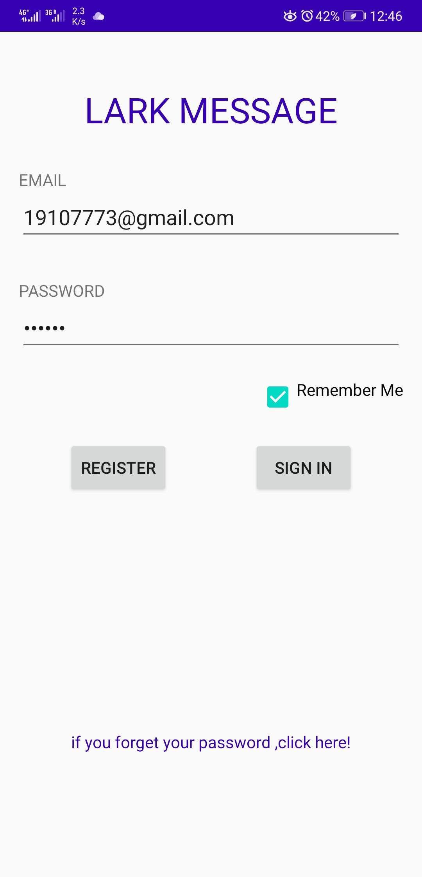

## Setting function:

We believe everyone have their favorite color which can make you happy! So, you can choose a color for every page to make yourself happy! We will record it and upload to our databse. So,after that you can see your own style in any devices.

